Food Management System

Use-Case-Realization Specification: Logout

Version <1.0>

Revision History

|  |  |  |  |
| --- | --- | --- | --- |
| **Date** | **Version** | **Description** | **Author** |
| <24/12/2020> | <1.1> | Final Draft | Nguyen Thi Ngoc Anh |

Table of Contents

1. Introduction 2

1.1 Purpose 2

1.2 Scope 2

1.3 Definitions, Acronyms, and Abbreviations 2

1.4 References 2

1.5 Overview 2

2. Flow of Events—Design 2

3. Derived Requirements 2

Use-Case-Realization Specification: Logout

# Introduction

## Purpose

This document describes how the Logout Use-Case is realized within the design model, in terms of collaborating objects.

## Scope

This document applies to the Food Management System which will be developed by TAT Restaurant.

## Definitions, Acronyms, and Abbreviations

User – a person who use the system.

## References

None.

## Overview

In the following section, Use-Case Realization Specification of the Logout Use-Case of the Food Management System is provided in detail. The first section is a textual description of the Use-Case specification. The following section contains diagrams (sequence and collaboration diagrams) describing how the use case is realized in terms of collaborating objects. The third section includes class diagrams with relationships that participate in the realization of the use case. The last section is an analysis of all requirements, such as non-functional requirements, on the use-case realization that are not considered in the design model, but that need to be taken care of during implementation.

# Flow of Events—Design

**2.1. Use Case Specification (script)**

|  |  |
| --- | --- |
| **Use Case** | Logout |
| **Description** | A user logging out to the system |
| **Actor(s)** | User |
| **Flows of Events** |  |
| **Basic Flow** | |
| 1. The user chooses to sign-out.  2. The system removes the current authentication token of the user.  3. The system logging out the user. | |
| **Alternative Flows** | |
| None. | |
| **Pre-conditions** | |
| The user is logged in the system. | |
| **Post-conditions** | |
| The user return to homepage as guest. | |
| **Extension Points** | |
| None. | |

**2.2. Sequence Diagram:**

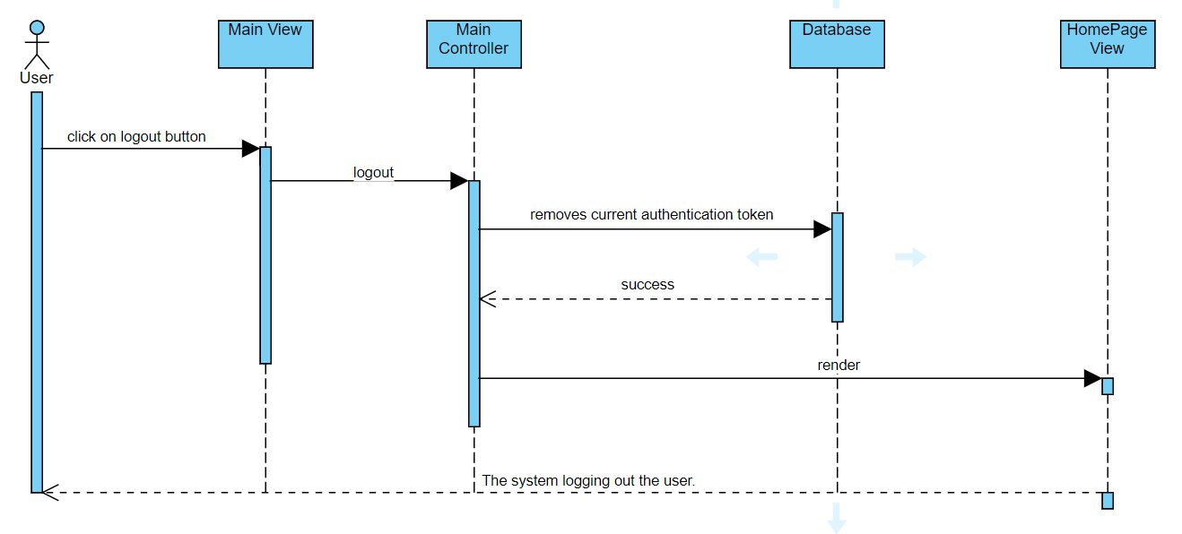

**2.3. Class Diagram:**

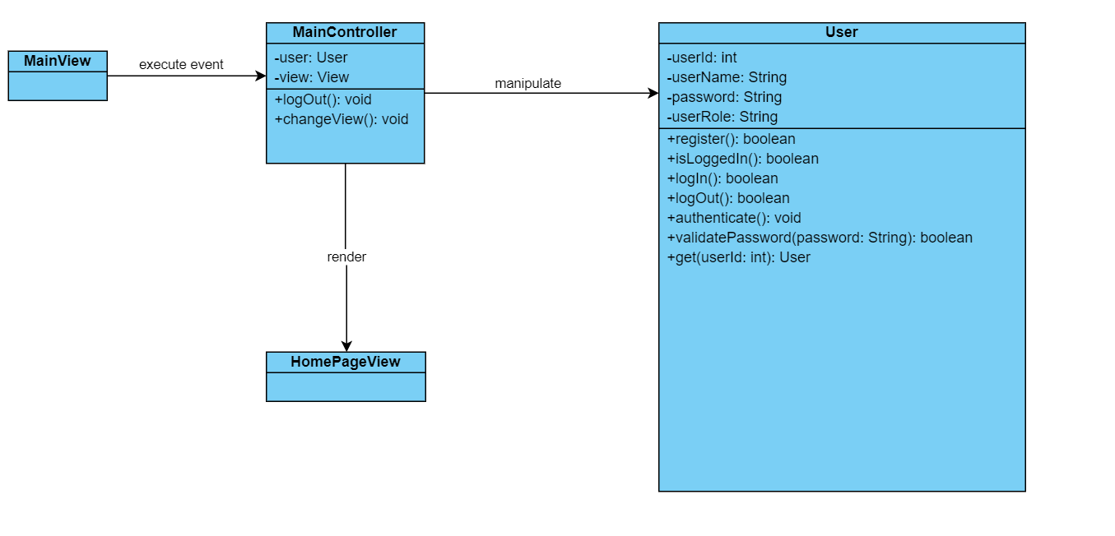

# Derived Requirements

None.